|  |
| --- |
| Circle Language Spec: Commands |

## Changing Inactive to Executable in a Diagram

The article *Changing Inactive to Executable* has already explained these effect conceptually. The current article further clarifies it with diagrams.

When you design a command definition, you might want to do it using an active command object:

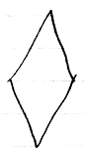

and test it once by running the active command definition:



After that you can change it to an inactive command definition and give it the appropriate default values.

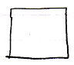

If you decide to change the inactive command definition back to an active command, then you can not run it again, because the command object has already run:



Others might still have a reference to it to be able to read its output.

If you want to run the command definition again, you are going to have to make a call to it instead:

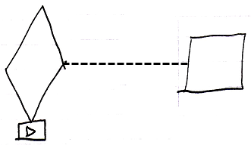

If you change an inactive command definition to an executable command definition:

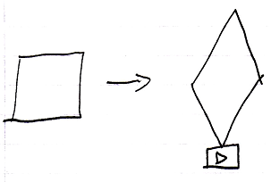

then you can all of a sudden run it, which may overwrite the executable’s default output values.